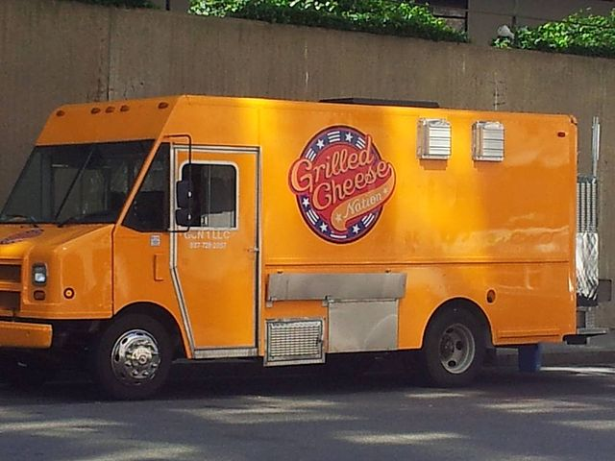
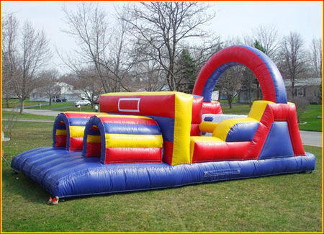
Patriots Day Celebration and Commemoration
210 Glassmaster Road
Lexington, SC 29072
September 10, 2022 12-4 pm
This Photo by Unknown Author is licensed under CC BY-SA
CELEBRATING OUR OEF/OIF VETERANS
AT DEPARTMENT HEADQUARTERS LOCATED AT 210 GLASSMASTER ROAD, LEXINGTON, SC 29072
SATURDAY SEPTEMBER 10TH, 2022 FROM 12-4 PM. CEREMONY FOR OEF/OIF VETERANS WITH A PINNING PRESENTATION BY HUMANA AT FROM 12-1 PM.
DJ TERRYOKE PLAYING FROM 11-2 AND THE 1 MORE ROUND BAND IS SET TO PLAY FROM 2-4 PM.
DUNK THE COMMANDER OR ANY COUNSEL MEMBERS FOR A DONATION OF $1.00 PER BALL TO GO TO T.A.P.S.
FOOD TRUCKS, BOUNCY HOUSES, FUN FOR ALL AT THIS FESTIVAL. OPEN TO THE PUBLIC, DONATIONS ARE APPRECIATED
PLEASE COME OUT AND ENJOY A DAY FILLED WITH FUN AND COMRADESHIP!

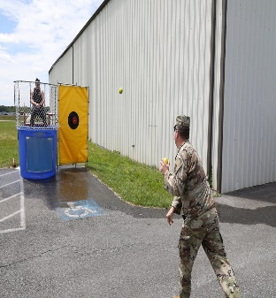
This Photo by Unknown Author is licensed under CC BY-ND

